VISAUL PROGRAMMING LAB

TOPIC:
CONCEPTS OF OOP

NAME:
MUHAMMAD TALHA
ROLL NUMBER:
241890
SECTION:
4/A

INSTRUCTOR:
Ms. AMNA TARIQ

TASK 3.1
Inheritance relationship between Rectangle and Cuboid.
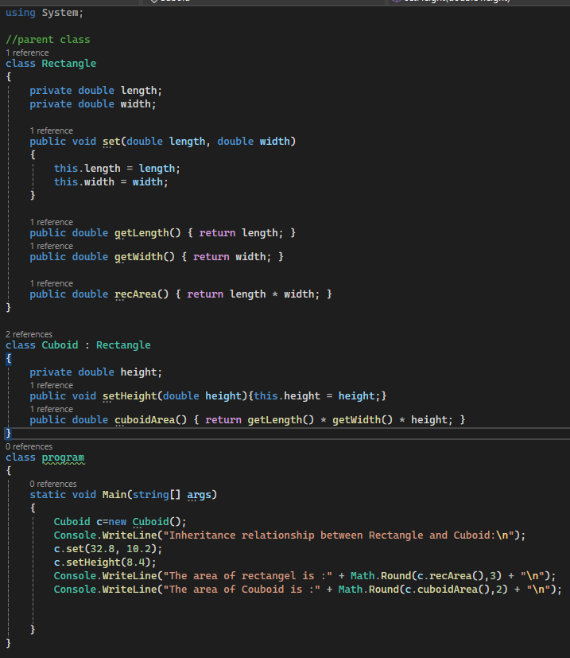

RESULTS:
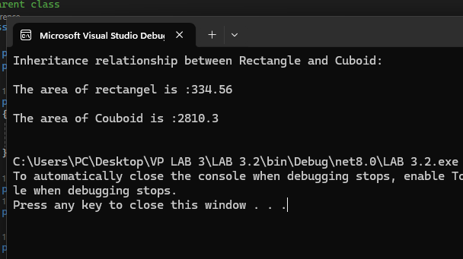

TASK 3.2
Create a class named Graduate Course
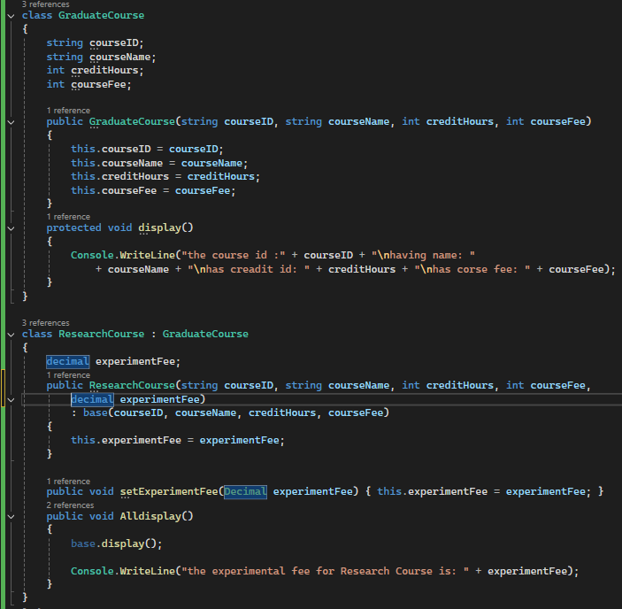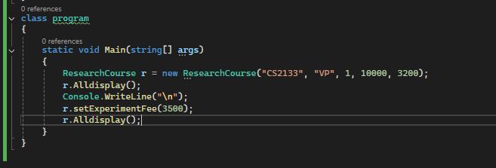
RESULTS: 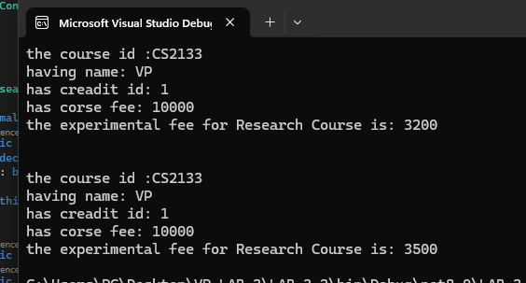

TASK 3.3
Create a base class named Animal
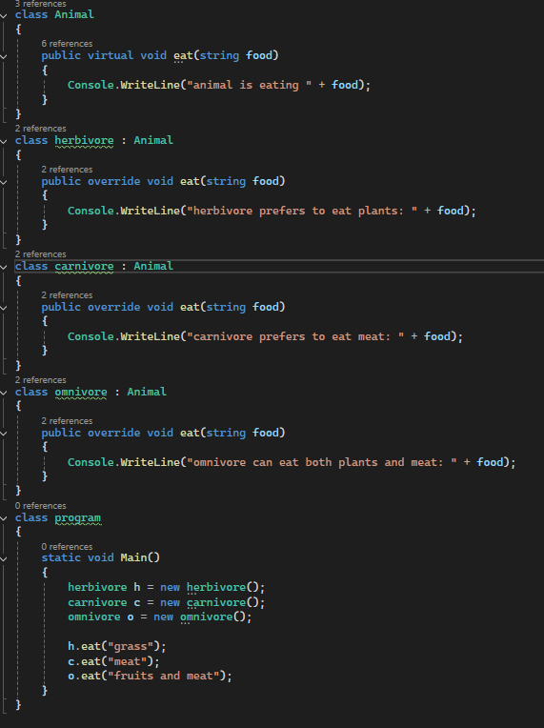
RESULTS:
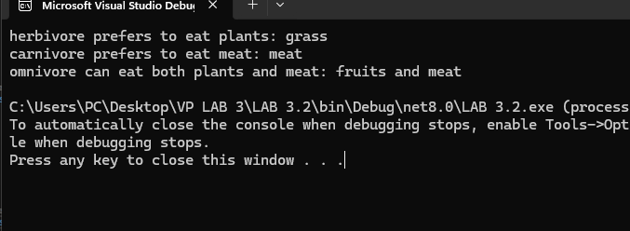

LAB TASK 3.4
Design a Vehicle Management System using abstract classes and interfaces in
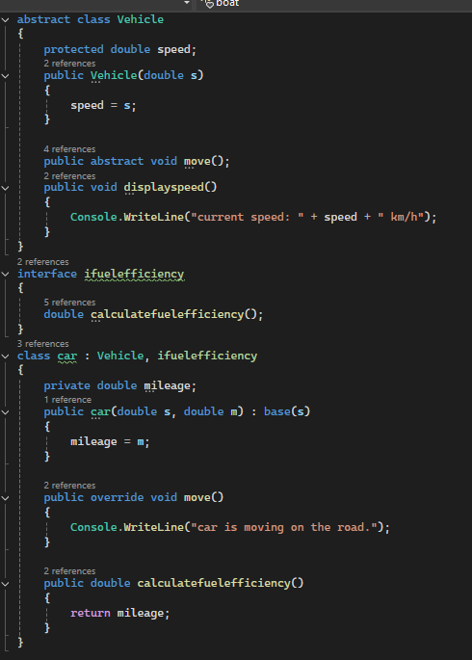
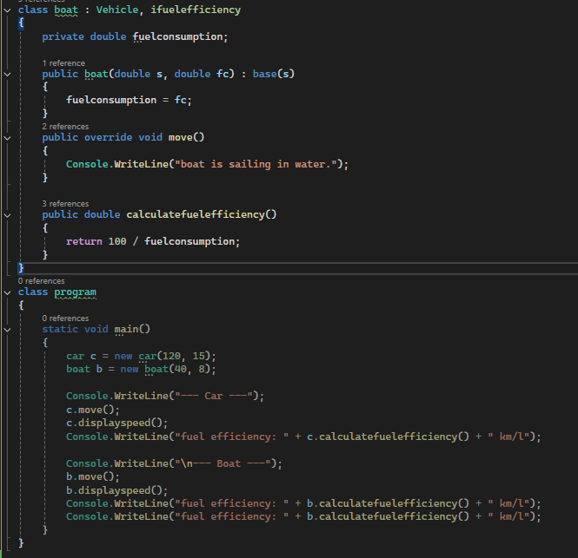
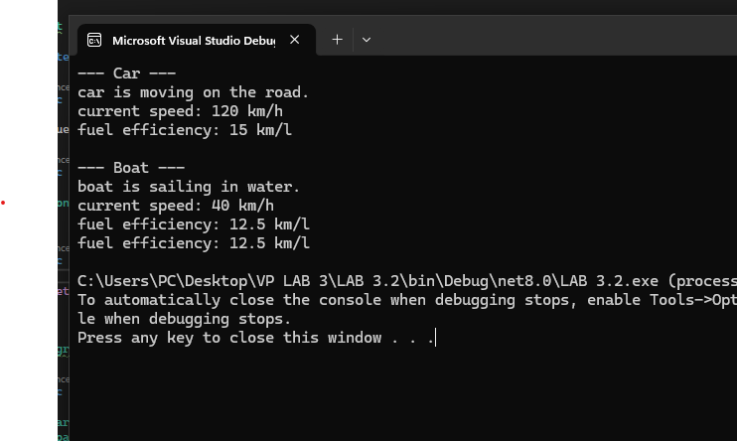
RESULTS:

